Austin Smothers

CSC 139

April 26, 2020

Homework 3

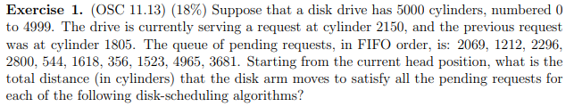

* FCFS:  
  |2150 - 2069| = 81  
  |2069 - 1212| = 857  
  |1212 - 2296| = 1084  
  |2296 - 2800| = 504  
  |2800 - 544| = 2256  
  |544 - 1618| = 1074  
  |1618 - 356| = 1262  
  |356 - 1523| = 1167  
  |1523 - 4965| = 3442  
  |4965 - 3681| = 1284  
  **Total movement: 13011**
* SSTF:  
  |2150 - 2069| = 81  
  |2069 - 2296| = 227  
  |2296 - 2800| = 504  
  |2800 - 3681| = 881  
  |3681 - 4965| = 1284  
  |4965 - 1618| = 3347  
  |1618 - 1523| = 95  
  |1523 - 1212| = 311  
  |1212 - 544| = 668  
  |544 - 356| = 188  
  **Total movement: 7586**
* SCAN:  
  |2150 - 2296| = 146  
  |2296 - 2800| = 504  
  |2800 - 3681| = 881  
  |3681 - 4965| = 1284  
  |4965 - 4999| + |4999 - 2069| = 2964  
  |2069 - 1618| = 451  
  |1618 - 1523| = 95  
  |1523 - 1212| = 311  
  |1212 - 544| = 668  
  |544 - 356| = 188  
  **Total movement: 7492**
* LOOK:  
  |2150 - 2296| = 146  
  |2296 - 2800| = 504  
  |2800 - 3681| = 881  
  |3681 - 4965| = 1284  
  |4965 - 2069| = 2896  
  |2069 - 1618| = 451  
  |1618 - 1523| = 95  
  |1523 - 1212| = 311  
  |1212 - 544| = 668  
  |544 - 356| = 188  
  **Total movement: 7424**
* C-SCAN:  
  |2150 - 2296| = 146  
  |2296 - 2800| = 504  
  |2800 - 3681| = 881  
  |3681 - 4965| = 1284  
  |4965 - 4999 - 4999 - 356| = 5389  
  |356 - 544| = 188  
  |544 - 1212| = 668  
  |1212 - 1523| = 311  
  |1523 - 1618| = 95  
  |1618 - 2096| = 451  
  **Total Movement: 9917**
* C-LOOK:  
  |2150 - 2296| = 146  
  |2296 - 2800| = 504  
  |2800 - 3681| = 881  
  |3681 - 4965| = 1284  
  |4965 - 356| = 4609  
  |356 - 544| = 188  
  |544 - 1212| = 668  
  |1212 - 1523| = 311  
  |1523 - 1618| = 95  
  |1618 - 2096| = 451  
  **Total Movement: 9137**

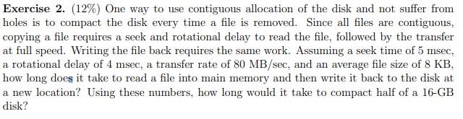

LI/O = Lseek + Lrotate + Ltransfer || Lseek = 5ms || Lrotate = 4ms

8KB:  
Ltransfer = 80MB/sec = .8MB/msec = 80KB/msec = 1msec/80KB 🡪 1msec/80KB * 8KB = 1/10 msec = *.1ms*  
LI/O = 5ms + 4ms + .1ms = *9.1ms = LI/O*   
**Total Time r/w = LI/O * 2 = 18.2ms**

Half of 16GB:  
16GB/2 = 8GB 🡪 8GB = 233B / (213B per file) = 220 files 🡪 220 files * 18.2ms/file = *19084083.2msec*  
19084083.2msec = 19084.0832s / (120s / hr) = **5.3 hours (19084.0832s) = Total Time**

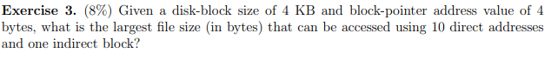

# ptrs/block = block size/disk address 🡪 4096B/4B = *1024 ptrs*

Total = (#direct + #indirect(#ptrs)1 + …) * block size

Total = (10 + 1024) * 4096 🡪 **Total = 4,235,264B = 4.235264GB**

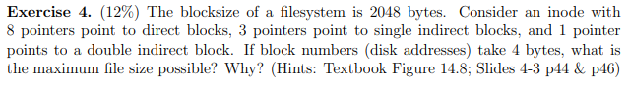

Number of ptrs/block = block size/disk address 🡪 2048B/4B = *512ptrs*

Total = (#direct + #indirect(#ptrs)1 + #double-ind(#ptrs)2 + …) * block size

Total = (8 + 3*(512) + 5122) * 2048 B (size) 🡪 **Total = 540,033,024B = 540.033024GB**